What is changing/or what needs to be communicated?
The My Patient and Unassigned filters now work correctly. They will show patients unassigned to your role – for example, if you are a physician they will show patients assigned to residents and APPs but not physician.

You must select “My Role Unassigned” in the dropdown next to the Unassigned filter button.

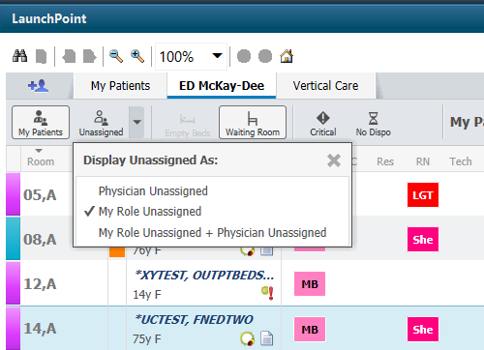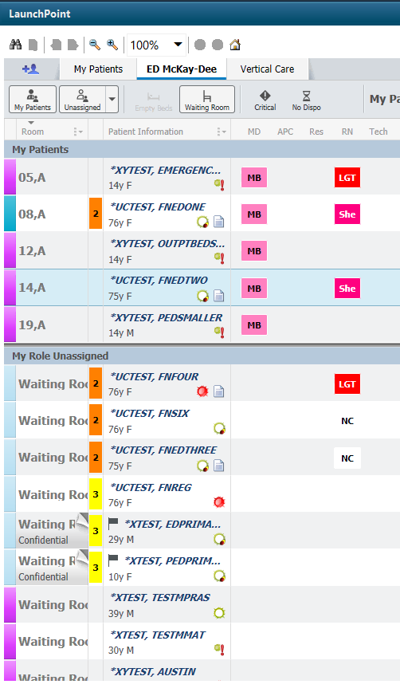

Physician Unassigned will continue to show you only those patient who have not been assigned to a qualified medical provider.
***This filter will also work for nurses – showing only those patients who have not been assigned to another nurse.

Why it’s changing?
This will allow physicians and nurses to more correctly see those patients they need to assign themselves to.

Who will it impact?
All ED physicians, residents, advanced practice providers, nurses and techs.

When it’s changing?
March 19, 2020

Who to contact if they have questions?

iCentra Users: Contact your local CTIS rounding resource, or call x-3456 option 2.

Care Transformation Caregivers: ED Clinical Informatics Team
Shelly Bowen shelly.bowen@imail.org
Lisa Gleed Thornton lisa.gleedthornton@imail.org
Jennifer Jensen jennifer.jensen3@imail.org

